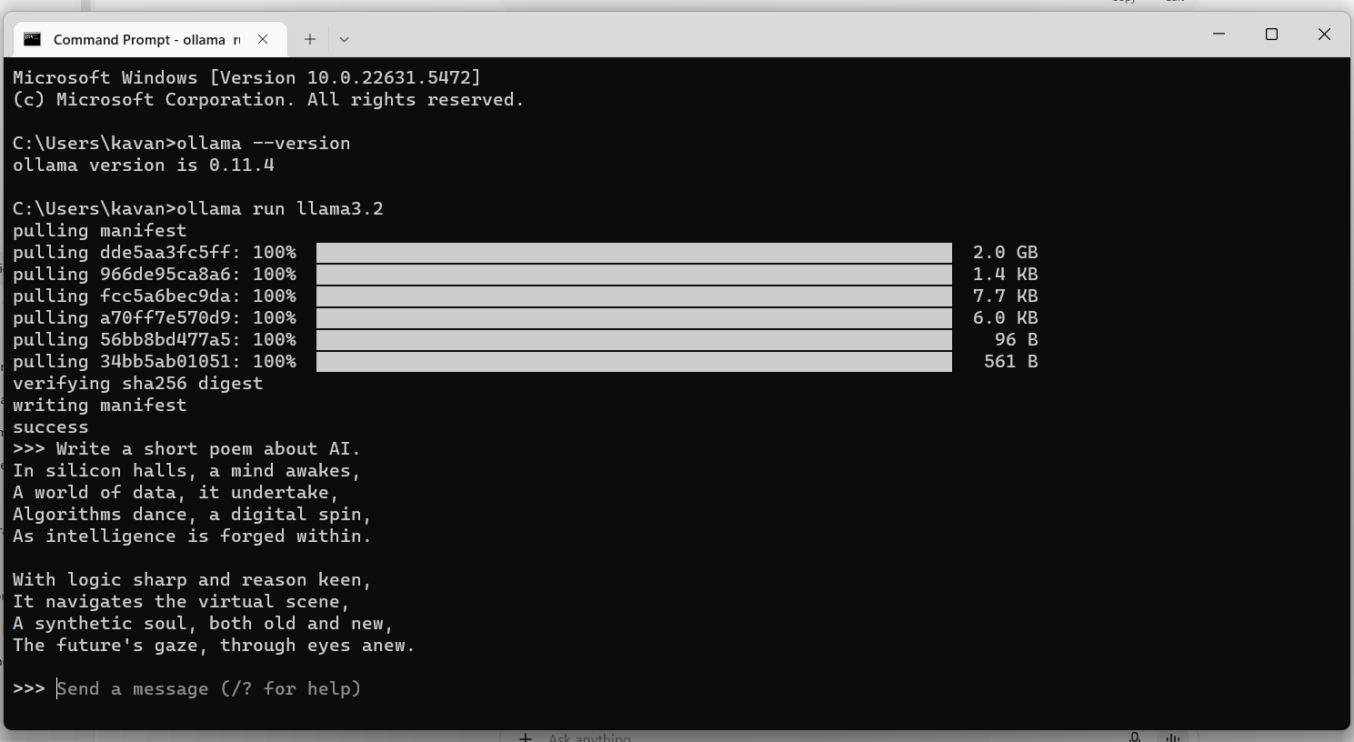
Result:

Performance and installation experience:
The installation process was straightforward. I downloaded the Ollama installer from the official website and set it up on Windows without any major issues. After confirming the installation using the ollama --version command, I proceeded to run the model llama3.2.
The first run required downloading the model weights, which was around 4GB. This step took a few minutes depending on my internet speed. Once the model was downloaded, it launched successfully in the Command Prompt with the >>> prompt, ready to accept input.
I tested it by asking:
Prompt: “Write a short poem about AI.”
The model responded within a few seconds, generating a short, creative poem. The response time after the first load was quite fast (about 3–5 seconds).
Overall, the installation experience was positive. Ollama made it easy to run a local LLM without complicated setup steps, and the model’s response quality was impressive for a fully local environment.

